AWESOME art and story courtesy @rippedup12:

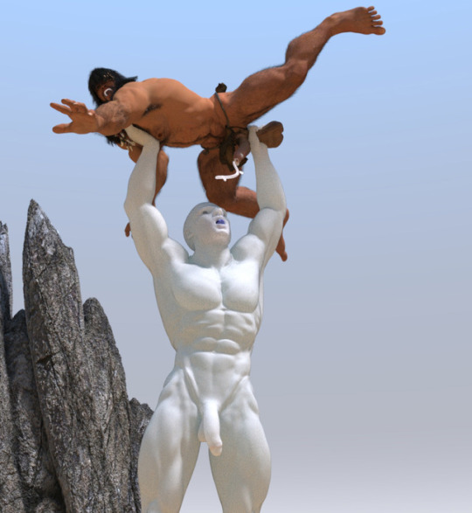

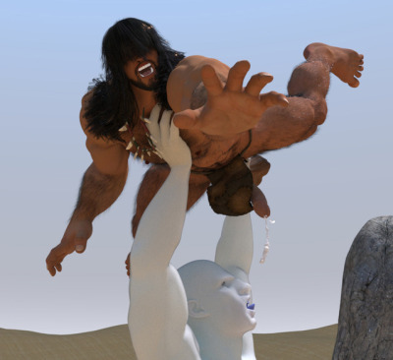

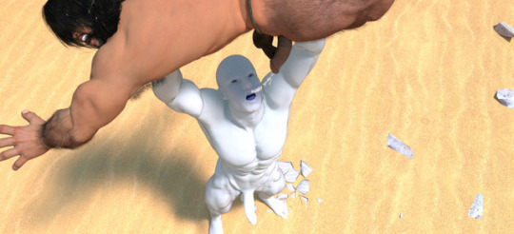

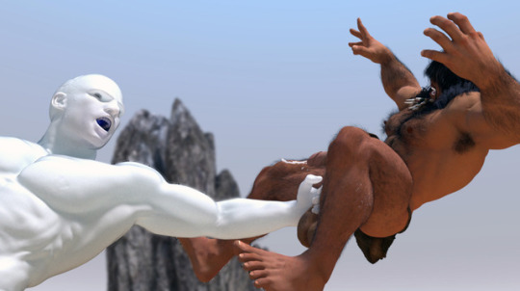

Anak continues his trek through the forbidden zone to find his young lover, and is ambushed by a hulking muscle bound giant with milky translucent skin. The giant grabs Arak’s large beautiful balls with its giant hand and crushes them. The barbarian cries out in pain and instantly crumples to the ground. The monster picks up the thickly muscled hairy barbarian by his nut sack and holds him over head. The monsters fingers dig into the hairy pectoral muscles of the young barbarian causing further agony. The giant stretches Arak’s scrotum almost tearing the massive balls from his body. The trapped testicles can only take so much abuse and finally start to give up their precious man milk. The giant greedily opens his mouth to catch every drop the young bull can produce from those giant nuts. Arak cries out as he is forced to shoot a thick wad of juice from his mighty shaft by his sadistic opponent. After the flow of semen stops, the muscled giant has no use for the handsome barbarian and swings him by his fist sized balls toward a rocky outcropping - surely this will be the end of the young hero, he will be smashed on the rocks or his balls will be ripped form his well muscled groin.

可怕的故事”的艺术courtesy rippedup12：

他的儿子继续跋涉至禁区找到他的两个年轻的承诺和冰ambushed A市hulking肌肉与translucent控巨乳白色的皮肤。《巨人grabs阿拉克的大球和它的美丽和巨人的手把他们。《野蛮人cries了在痛苦和instantly crumples的地面。《怪物thickly皮克下有毛的野蛮人的城市muscled坚果袋和他的团队在他头上。你的手指变成怪物的毛发pectoral年轻的野蛮人的肌肉的持续性agony。《巨人stretches阿拉克的阴囊是tearing《大球从他的身体。在做困testicles可以只带了这么多的滥用和终于开始放弃他们的宝贝你牛奶。《巨人greedily打开他的嘴抓住每一滴年轻的公牛从那些可以产生巨大的坚果。阿拉克cries出局，他用力一拍两个冰厚汁wad大学，他从他的sadistic轴城市强大的对手。在精子银行停止流动，有没有用muscled巨人的野蛮人和他英俊的swings他的拳头大小的球市toward一石outcropping康医药，这将是比年轻的英雄，他将smashed加冰或是他的球会被他的腹股沟muscled阱形状。

