大学恶作剧-夹蛋College hazing - the mangle

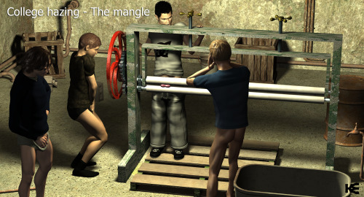

The mangle had been a test of courage for decades. The rules were simple:

1. Measure the thickness of the initiate’s balls

2. Open the mangle wheels and pull initiate’s balls through the rollers

3. Close the rollers to half the width of his thickest ball

4. Initiate must roll the wheel until his balls pass between the wheels

The others had all taken their turn and now it was Elliott’s turn. They took the measurements, but when they set the wheels, they set them to just one quarter of the thickness of his ball.

And now, Elliott pulled the wheel, slowed in pain, but afraid to look foolish in front of the others, he prepared to give the handle one massive pull…

大学里的恶作剧的影响

由于几十年来一直是勇气的测试。规则很简单：

1。测量提升球的厚度

2。打开损坏的轮子和拉球发起的通过滚轮

三.接近他的厚球的一半宽度的滚筒

4。启动必须滚动滚轮直到车轮之间通过他的球

其他人都轮流，现在轮到埃利奥特。他们接受了测量，但是当他们把轮子放好的时候，他们只给了他四分之一的厚度。

现在，埃利奥特拉了轮子，放慢了疼痛，但害怕在别人面前显得愚蠢，他准备给把手一个巨大的拉力…